JAVA LAB PROGRAM 9

class BMSThread extends Thread {  
    public void run() {  
        try {  
            while (true) {  
                System.out.println("BMS College of Engineering");  
                Thread.sleep(10000);  
            }  
        } catch (InterruptedException e) {  
            System.out.println("Thread interrupted: " + e.getMessage());  
        }  
    }  
}  
  
class CSEThread extends Thread {  
    public void run() {  
        try {  
            while (true) {  
                System.out.println("CSE");  
                Thread.sleep(2000);  
            }  
        } catch (InterruptedException e) {  
            System.out.println("Thread interrupted: " + e.getMessage());  
        }  
    }  
}  
  
public class DisplayThreads {  
    public static void main(String[] args) {  
        BMSThread bmsThread = new BMSThread();  
        CSEThread cseThread = new CSEThread();  
  
        bmsThread.start();  
        cseThread.start();  
    }  
}

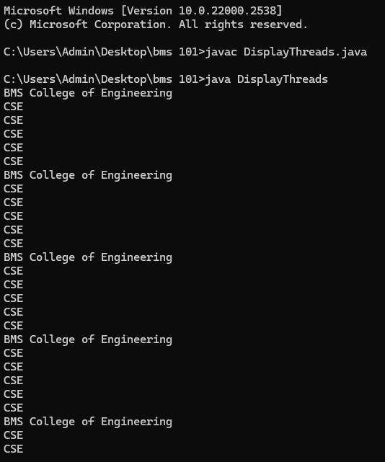OUTPUT